WEEK 5: Multi-Area OSPF Configuration(10)
🎯 Objective
- Implement scalable routing using OSPF Multi-Area Design
- Reduce routing overhead
- Configure backbone (Area 0) and non-backbone areas

🗺️ Topology (Example)
LAN1 --- R1 --- R2 --- R3 --- LAN2 |Area 0|Area 1|
🛠️ Step 1: Configure IP Addressing
R1
interface g0/0 ip address 192.168.1.1 255.255.255.0 no shutdown interface g0/1 ip address 10.0.12.1 255.255.255.252 no shutdown
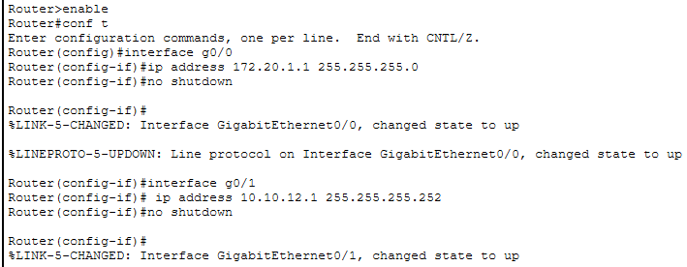
R2
interface g0/0 ip address 10.0.12.2 255.255.255.252 no shutdown
interface g0/1 ip address 10.0.23.1 255.255.255.252 no shutdown
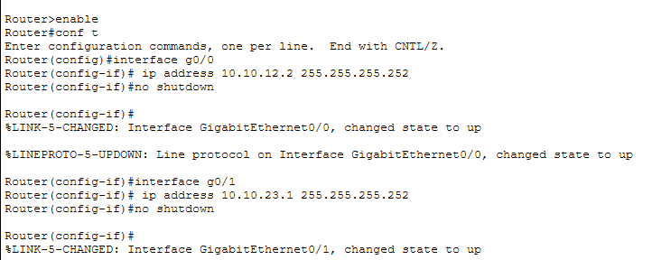
R3
interface g0/0 ip address 10.0.23.2 255.255.255.252 no shutdown interface g0/1 ip address 192.168.2.1 255.255.255.0 no shutdown
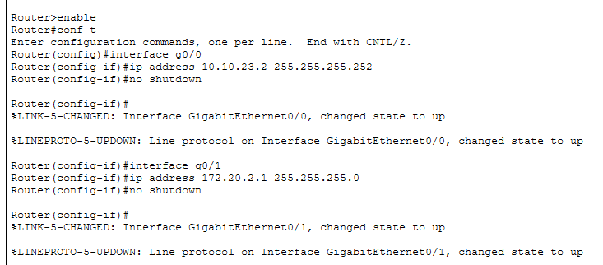
🛠️ Step 2: Configure OSPF Areas (10 Marks)
R1 (Backbone Area 0)
router ospf 1 network 192.168.1.0 0.0.0.255 area 0 network 10.0.12.0 0.0.0.3 area 0
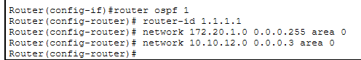

R2 (ABR – connects two areas)
router ospf 1 network 10.0.12.0 0.0.0.3 area 0 network 10.0.23.0 0.0.0.3 area 1
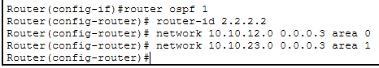
R3 (Area 1)
router ospf 1 network 10.0.23.0 0.0.0.3 area 1
network 192.168.2.0 0.0.0.255 area 1
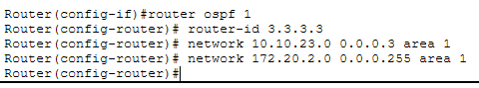
✅ Verification
show ip ospf neighbor show ip route ospf
